**Problem statement**

Big Mountain Resort is looking to make changes to ticket prices as there have been suspicions it is not capitalizing off of its facilities as much as it could. As a result, we are looking to determine what the optimal ticket pricing will be based on Big Mountain’s current facilities, as well as what potential changes can be made to further increase profitability. Due to a recent install of a new chair lift to increase visitor distribution across the mountain, we are looking to increase revenue to make up for this expense by at least $1,540,000 for this next skiing season.

**Data Wrangling**

To look into the optimal pricing strategy based on Big Mountain’s features, we are using data from over 300 different resorts across the country so we can compare and contrast what different resorts charge for their ticket prices and see what features accompany those prices. We can then build a machine learning model to predict what Big Mountain should be charging based on their features through the lens of what other resorts are charging and determine what opportunities are available with ticket prices to increase revenue.

**Exploratory data Analysis**

After reviewing the data provided and cleaning the data to make sure it is valid for our models, we found that there is no significant difference when it comes to the state/region the resort is at. This means that we are not taking into consideration what state the resort is in, just its price and features for our model. After the initial analysis, we noticed the following potential correlations in the data in relation to ticket price.

The higher the Vertical Drop, the Higher the Ticket Price

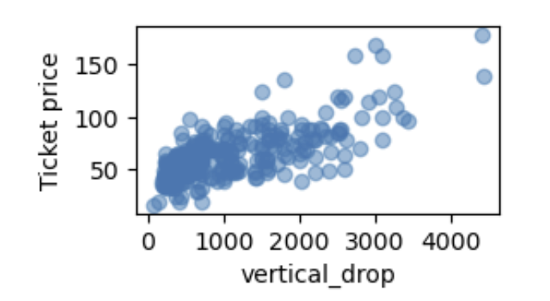

The more Fast Quads, the Higher the Ticket Price

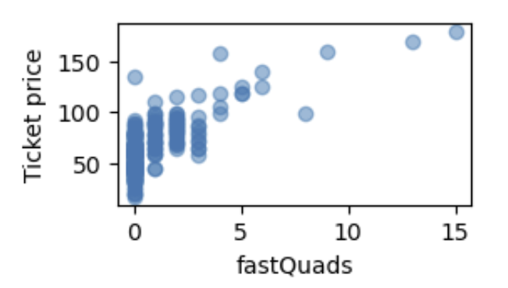

The more Runs, the Higher the Ticket Price

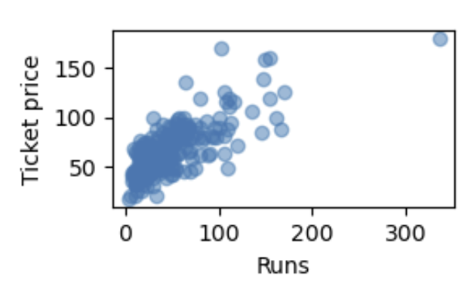

The more Total Chairs, the higher the Ticket Price

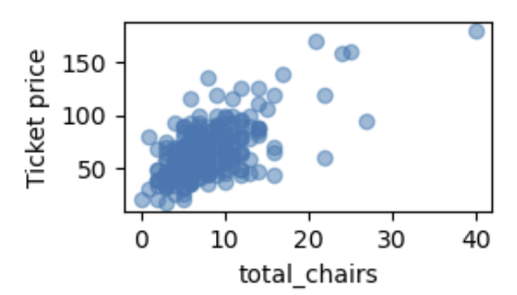

The more Snow Making, the Higher the Ticket Price

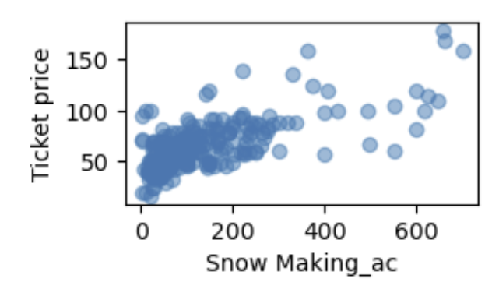

Making note of these observations, we moved into creating our machine learning models to see what features truly impacted the ticket price.

**Model Preprocessing with feature engineering**

Our initial step was to see what the average price of all resorts combined would be. We found this to be $63.81. We created two different types of models, a linear model and a random forest model to see which model was more precise. For the linear model, it performed the best when considering the top 8 features as that produced the least amount of error and variability.

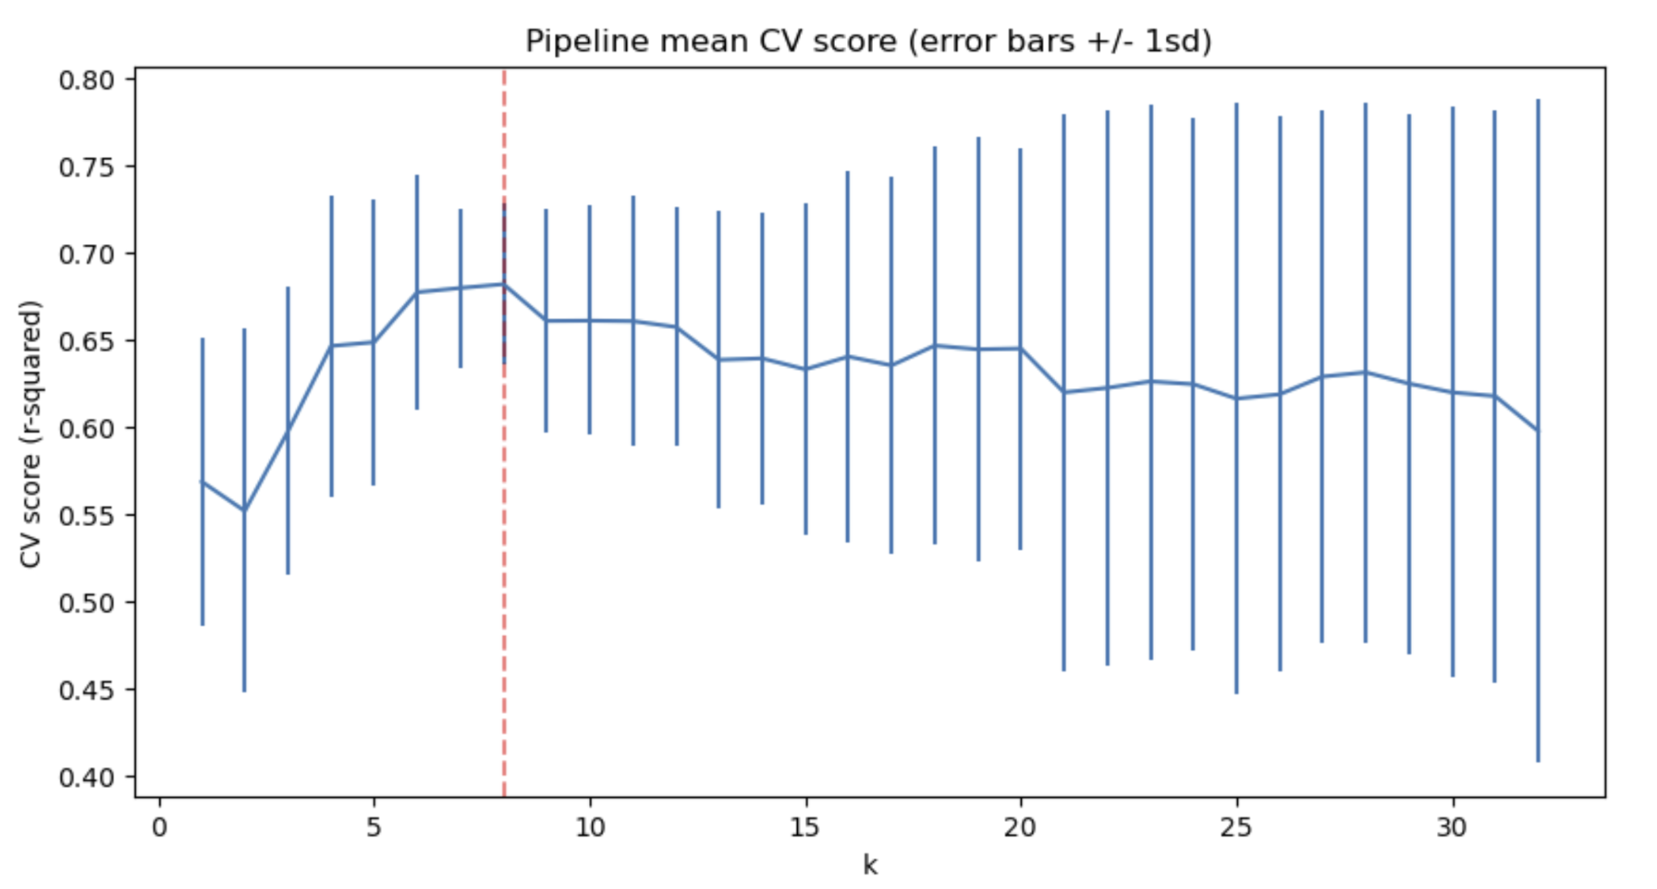

The corresponding 8 features are as follows (Higher the number, the greater the impact positively or negatively):

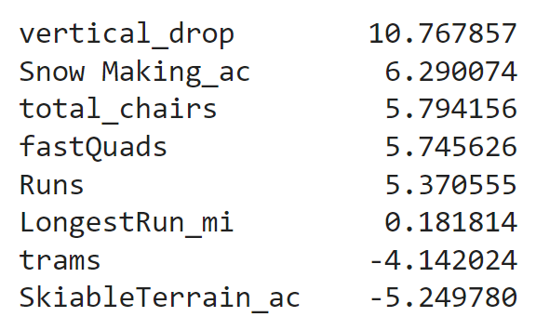

For the Random Forest model, we found there were 4 dominant features:

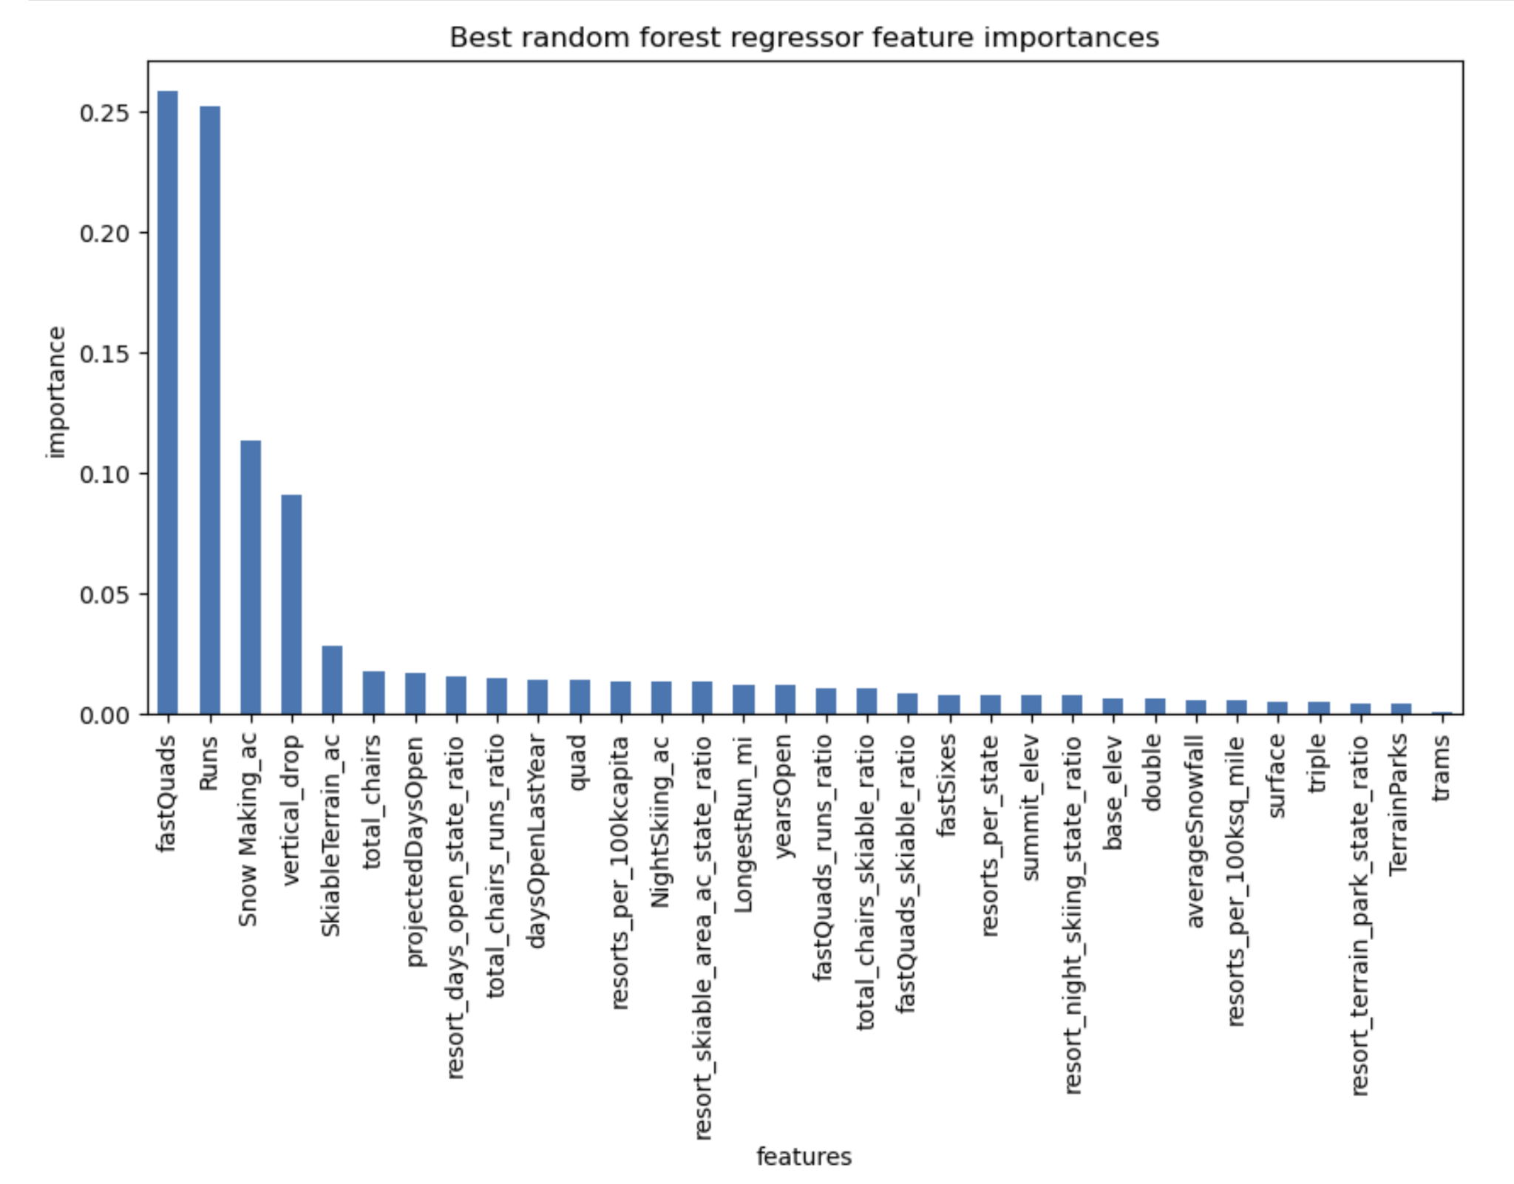

1. fastQuads
2. Runs
3. Snow Making_ac
4. vertical_drop

Now that we have the best performing versions of the two models, we compared them with the mean absolute error and found that the Random Forest model had the lower error by $1 so we decided to continue the modeling with the Random Forest model.

**Scenario modeling**

For our model, we first started at a baseline of what Big Mountain charges for ticket prices ($81). Then putting Big Mountain through the model, we found that the expected ticket price for Big Mountain was $95.87, with a mean absolute error of $10.39. This means that even at the furthest level of error, the model would still show that Big Mountain is currently undercharging and has room for increase for its ticket price up to $85 at a minimum.

The first run of the model showed that with Big Mountain’s current features, the ticket price should be increased. However, there were four business proposals that are up for consideration as an additional way to increase revenue.

1. Permanently closing down up to 10 of the least used runs. (Does not impact any other resort statistics)
2. Increase the vertical drop by adding a run to a point 150 feet lower down but requiring the installation of an additional chair lift to bring skiers back up, without additional snow making coverage.
3. Same as number 2, but adding 2 acres of snow making cover.
4. Increase the longest run by 0.2 mile to boast 3.5 miles length, requiring an additional snow making coverage of 4 acres.

We ran these scenarios through our model to see how the ticket price would be impacted.

*Scenario 1*

We looked at how ticket price is impacted as more and more runs are shut down.

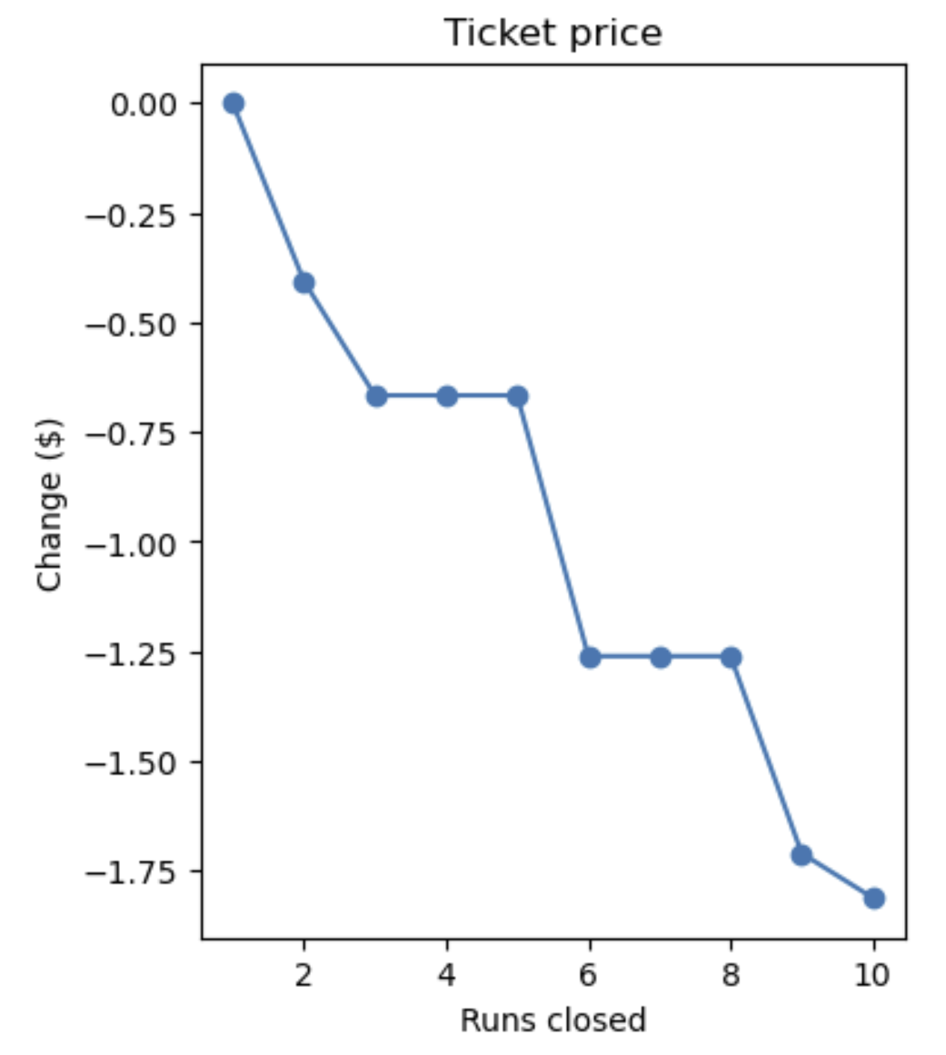

We found that closing 1 run has no impact on ticket price. Closing 2 and 3 provide more significant drops in ticket prices. However, once 3 are closed, there is no impact to closing a 4th and 5th run. Then closing a 6th run creates another significant drop in ticket price. As a result, we recommend closing either 1 run, or 5 runs as the most optimal strategies.

*Scenario 2*

We found that adding a Vertical Drop of 150 and a new run would increase ticket price by $1.99. With the average number of visitors over the season, we would expect this to be an additional $3,474,638 in Revenue with this increase in ticket price alone.

*Scenario 3*

We found that doing scenario 2 with an addition of 2 acres of snow making cover provided no extra benefit for ticket price (the same $1.99 increase as scenario 2), so it would not be worth pursuing.

*Scenario 4*

We found that increasing the longest run by .2 miles and adding an additional 4 acres of snow making coverage also did not provide any benefit to ticket price. As a result, we would not recommend pursuing this option as well.

**Pricing recommendation and Conclusion**

The recommendation at this time is to increase the ticket price to $85 which is the conservative end of what the Random Forest model would recommend for Big Mountain’s ticket price. Then repurposing a run and increasing the vertical drop by 150 feet (combining scenarios 1 and 2) would support an additional increase in ticket price of $1.99 creating over $3 million in added revenue to support any additional operating costs.

**Future scope of work**

The current model does not take into account operating costs for these other resorts, so that may be useful in providing further insight into what goes into these ticket prices. This would help with accuracy on who is pricing properly and who is over/underpricing so we can take that into account in the model and increase accuracy. It may be useful as well to create an easy way to run different scenarios through the model for quick and concise reports on how different ideas would affect the ticket price.